Report for SVM models:

1. SVM Method: A support vector machine is a classifying technique where all the data is discriminated based on the characteristics and with a hyperplane dividing the data*. Also, the test data can be categorized based on the training set. In two-dimensional space, each data can be put on either side depending on the category.*
2. Support Vectors: Support vectors are the data points that lie closest to the decision surface (or hyperplane)

• They are the data points most difficult to classify

• They have direct bearing on the optimum location of the decision surface.

1. **Difference between Ovo and Ovr:**

1.The number of classifiers we use and have to learn in this process is different, these factors correlate a lot with decision boundary that gets created.

2. OVA needs to train L classifiers

OVO needs to train L(L-1)/2 classifiers

3. OVO is faster than OVA in this case where the binary classifier needs 0(n (power of 1.xx))

4. Kernel SVM solver : OVO

linear SVM solver : OVA

1. **explain what was your criteria for selecting the two attributes:** Instead of selecting any two attributes, I have used the SelectKbest with k = 2 to get the best 2 attributes.
2. **Visualize SVM in a 2D projection for linear, and non-linear kernels:**

**Linear SVM:**

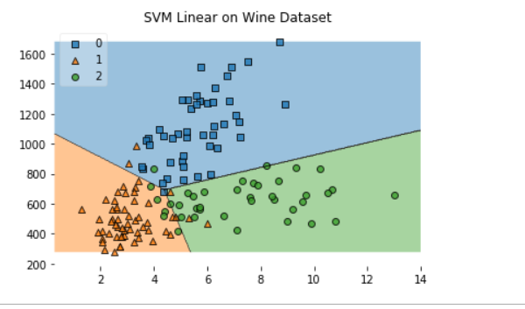

**Non – Linear SVM:**

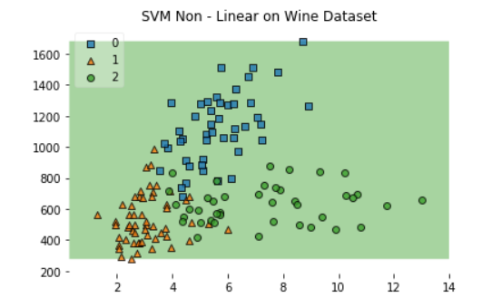

**Interpret and compare the results:**

**Non – Linear svm:**

The confusion Matrix for the SVM Non - linear Kernel is:

[[ 0 0 15]

[ 0 0 22]

[ 0 0 17]]

**The classification Report for the SVM Non -linear Kernel is:**

**precision recall f1-score support**

0 0.00 0.00 0.00 15

1 0.00 0.00 0.00 22

2 0.31 1.00 0.48 17

avg / total 0.10 0.31 0.15 54

In the Non – Linear SVM,

Precision : 0.10

Recall: 0.31

F1 – Score: 0.15

**Linear SVM:**

The confusion Matrix for the SVM linear Kernal is:

[[19 0 1]

[ 1 18 1]

[ 0 1 13]]

The classification Report for the SVM linear Kernal is:

precision recall f1-score support

0 0.95 0.95 0.95 20

1 0.95 0.90 0.92 20

2 0.87 0.93 0.90 14

avg / total 0.93 0.93 0.93 54

In the Linear SVM,

Precision: 0.93

Recall: 0.93

F1-Score: 0.93

Hence, Precision, Recall and F1 Score are better for SVM linear model

for this dataset rather than SVM Non – Linear model.